Handover of well NO 34/4-19 S Omega S

The well responsibility is hereby transferred
From D&W to the asset (permanent plugged, temporary abandoned well)

Signatures

I have reviewed the handover documentation and accept the handover of the well based on the information provided in this document and its references.

__________________ ___________ ______________________ ___________
D&W OC Leader Date License Responsible Date

Table of contents

1 Handover Certificate from D&W to O&M 3
1.1 Design confirmation 3
1.2 Well design 3
1.3 WBS well barriers 4
1.4 Pressure test charts 5
1.5 Non-conformances 7
1.6 Visual survey of seabed 8
1.6.1 Visual survey of the well location including potential pilot well 8
1.6.2 Visual survey of the well location including potential pilot well 8
1.7 Document findings 8
1.8 Samples 8

Handover Certificate from D&W to O&M

Design confirmation
The well is handed over from D&W according to governing requirements and with qualified barriers established.

D&W Scope and findings

Well design
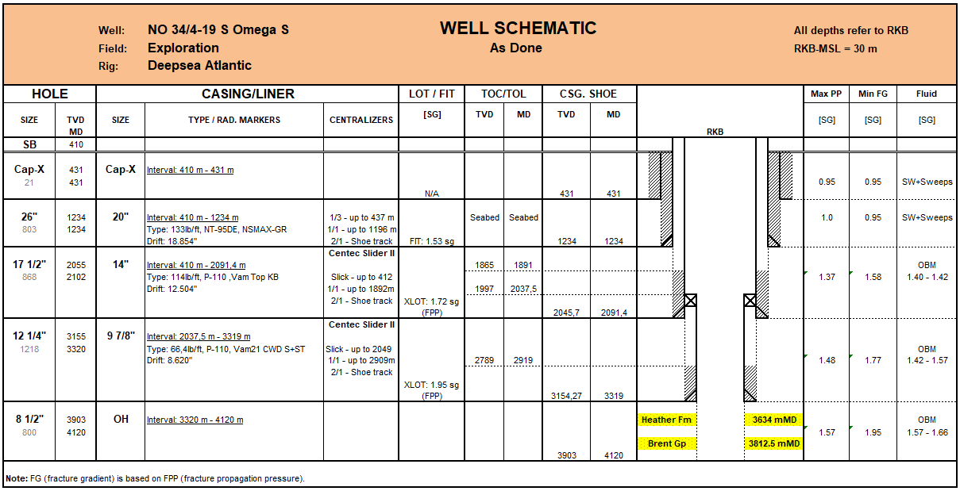

WBS well barriers
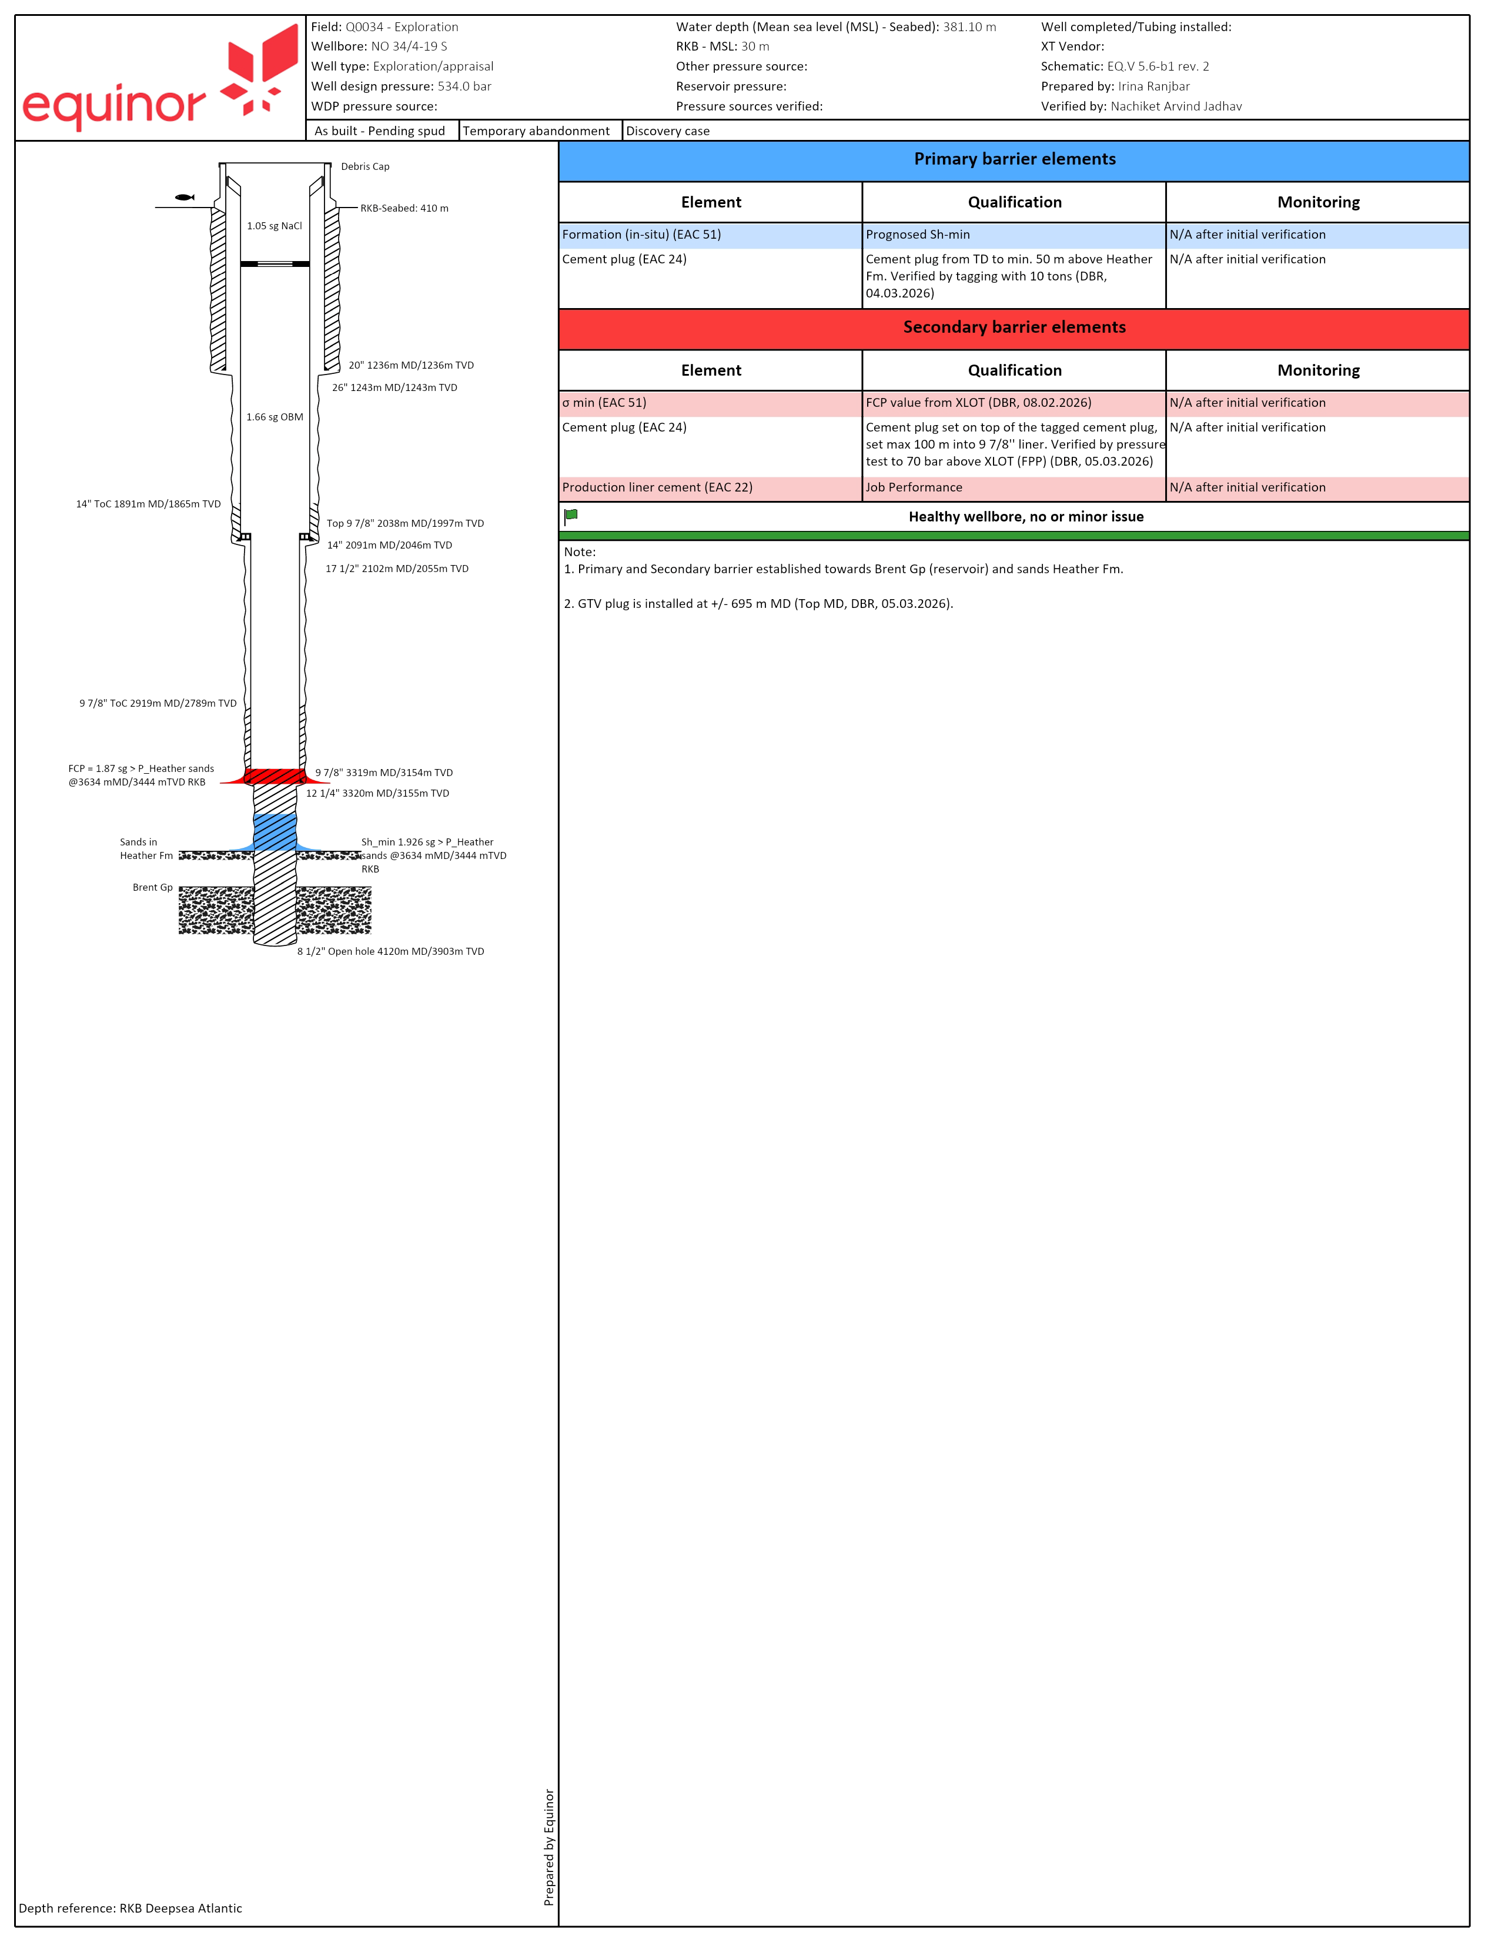

Pressure test charts

The casing strings have been tested to the following pressures:
Casing size |  | Surface pressure | Mud weight | Operation Date
34/4-19 S | 20” casing | 172 bars | 1.03sg SW | 28.01.2026
 | 14” casing | 502 bars | 1.42sg OBM | 03.02.2026
 | 9 7/8” liner | 310 bars | 1.58sg OBM | 07.02.2026
Note: Casing and top of cement (TOC) depths are specified in the Well Schematic in chapter 1.2

Pressure Test of 20’’ casing

20’’ casing was tested to 170 bars (DBR # 8, 28/01/2026).

Pressure Test of 14’’ casing

14’’ casing was tested to 502 bars (DBR # 14, 03/02/2026).

Pressure Test of 9 7/8’’ liner

9 7/8’’ liner was tested to 310 bars (DBR # 18, 07/02/2026).

Non-conformances
N/A

Visual survey of seabed

Visual survey of the well location including potential pilot well

ROV seabed survey has been taken on March 6th, 2026, and is located on 34/4-19 S Omega S SharePoint (Report and archive à Asset EOW documents à End of well from other Vendors).

Visual survey of the well location including potential pilot well

N/A

Document findings
CAP-X area is free for debris (manmade objects, concrete residues excluded.) No bubbles and NO visible seepage have been observed.

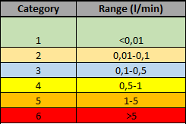

Well no. | Depth | Debris | Time start survey at seabed | Time stop survey at seabed | Bubbles observed | Rate | Category | Gas sample
34/4-19 S | 376 m | N/A | 06:25:22 | 06:26:50 | N | n/a | 1 | N

Samples

N/A

Samples to be sent to: Applied Petroleum Technology AS, Instituttveien 18, 2007 Kjeller. Attn: Geir Hansen / Per Erling Johansen

Observation program
If temporary abandonment reference is made to TR3507 SR-124954

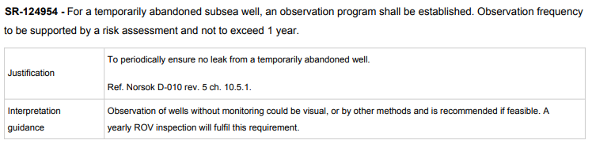

If temporary abandonment reference is made to TR3507 SR-131849